Error Message Functional Tests
  - Red Team | Peer Feedback Issue #141 | Verify Error Messages Work Correctly
Project: Moffat Bay Lodge | Course: CSD 460
Description: Browser tests for validation messages and error states | Date tested: 10/11/2026
Developer: Tiffany Davidson, Rashai Robertson, Bryan Covarrubias, Matthew Rozendaal | Peer tester: Tiffany Davidson
Instructions: Start the combined website/API server. Perform each step exactly as written. Record Pass or Fail, the actual message, and a screenshot for each test. Do not mark any test passed before checking it in your own browser.

Where every error appears
Page / function | Where to look | Condition
Login | login.html | Under the Login button: #login-message | Wrong email/password, API failure, connection failure
Login email/password fields | Browser validation bubble at the field | Invalid email text such as test, or empty required field
Register | register.html | Below Create Account: #register-message | Weak/mismatched password; duplicate email; API/server failure
Registration required fields | Browser validation bubble at the field | Missing field or malformed email blocks submission
About / Contact | about.html#contact | Below Send Message: #contact-message | Missing full name, email, subject, message; server failure
Contact email field | Browser validation bubble at the field | A nonempty invalid email such as test may block submission first
Booking | reservation.html | Below Add Room button: #reservation-message | Missing dates, unavailable rooms; not logged in (if form is shown)
Booking cart | Under each added room: .room-cart-item .error | Unavailable room appears as red status after availability refresh
Summary | reservation-summary.html | Beneath Confirm Reservation: #summary-message | No stored cart; availability failure; missing login at confirmation
History | reservation-lookup.html | Above reservations table: #history-message | Bad filter dates; no matches; failed history API; no reservations
History, signed out | Redirect to login.html, not an inline error | History requires a signed-in user
Important: An input containing "test" does not display an app error while typing. Most email inputs use the browser's built-in validation when Submit is clicked. The browser may show a tooltip instead of the page's styled message. Record that result separately.

Test setup
Use http://127.0.0.1:8000 after starting MySQL on port 3308 and running python src/api/startup_api.py from the project root. Test account: demo@moffatbay.com / DemoPass1 (only if the sample database is loaded). Sign out or use a private window to test registration or signed-out behavior. Use future check-in dates for bookings, and avoid confirming unnecessary test reservations.

Manual test cases

FT-ERR-01: Login: invalid email and missing password
Objective: Confirm that browser input validation prevents incomplete login before an API request.
Step | Action | Expected result | Developer pass/fail | Tester pass/fail + screenshot
1 | Open http://127.0.0.1:8000/login.html. | Login page displays Email Address and Password. | Pass | Pass  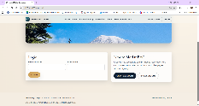
2 | Enter test in Email Address and any password, then click Login. | Browser flags Email Address as invalid; no sign-in occurs. | Pass | Pass  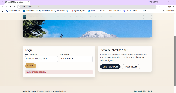
3 | Replace email with demo@moffatbay.com, clear Password, then click Login. | Browser flags required Password. No sign-in occurs. | Pass | Pass  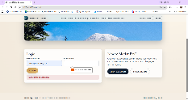
4 | Screenshot the invalid email or empty password feedback. | Browser feedback is visible next to the field, not the #login-message area. | Pass | Pass
Notes | Login error messages appear as expected.

FT-ERR-02: Login: incorrect password
Objective: Verify login rejects bad credentials without revealing which detail was wrong.
Step | Action | Expected result | Developer pass/fail | Tester pass/fail + screenshot
1 | Open login.html, enter demo@moffatbay.com. | Known seeded account email is entered. | Pass | Pass  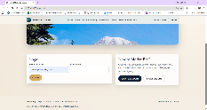
2 | Enter WrongPassword1 and click Login. | Login does not redirect. | Pass | Pass  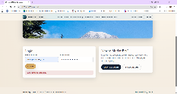
3 | Look immediately below the Login button. | Red #login-message shows "Invalid email or password." | Pass | Pass
4 | Screenshot the error message. | Screenshot shows the URL, entered email and red message. | Pass | Pass
Notes | Login error messages all display as expected.

FT-ERR-03: Registration: email and required fields
Objective: Confirm the browser blocks malformed email and blank required information.
Step | Action | Expected result | Developer pass/fail | Tester pass/fail + screenshot
1 | Open register.html. Enter test for email and valid values for other fields. | Form accepts typed input; no app message is required yet. | Pass | Pass  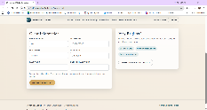
2 | Click Create Account. | Browser reports an invalid email at the email field. | Pass | Pass  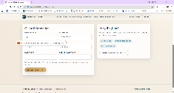
3 | Correct email, clear First Name, click Create Account. | Browser reports First Name is required and does not submit. | Pass | Pass  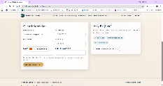
4 | Screenshot one validation bubble. | Feedback is visible by the invalid field, not necessarily #register-message. | Pass | Pass
Notes | Registration errors all display as required.

FT-ERR-04: Registration: weak password
Objective: Check the app-level password rule message.
Step | Action | Expected result | Developer pass/fail | Tester pass/fail + screenshot
1 | Open register.html and fill email, phone, first/last names with valid entries. | Required fields are complete. | Pass | Pass  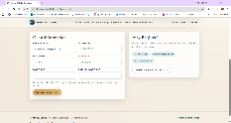
2 | Enter password123 in Password and Confirm Password. | Password is missing an uppercase letter. | Pass | Pass  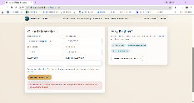
3 | Click Create Account. | Below button, red #register-message states: "Password must be at least 8 characters with one uppercase letter, one lowercase letter, and one number." | Pass | Pass
4 | Screenshot the message. | Registration is blocked; no redirect. | Pass | Pass
Notes | Password error message displays as required

FT-ERR-05: Registration: passwords do not match
Objective: Check the mismatched confirmation message.
Step | Action | Expected result | Developer pass/fail | Tester pass/fail + screenshot
1 | Open register.html and fill all fields; use unique email. | All required inputs are filled. | Pass | Pass  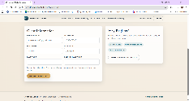
2 | Enter StrongPass123 as Password and DifferentPass123 as Confirm Password. | Passwords satisfy complexity but differ. | Pass | Pass  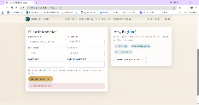
3 | Click Create Account. | Below button, red #register-message says "Passwords do not match." | Pass | Pass
4 | Screenshot the message. | Account was not created; page stays on Register. | Pass | Pass
Notes | Password difference error displays as required

FT-ERR-06: Registration: duplicate email
Objective: Check that a previously registered email is rejected with useful text.
Step | Action | Expected result | Developer pass/fail | Tester pass/fail + screenshot
1 | Open register.html in a signed-out/private browser session. | Registration form loads. | Pass | Pass  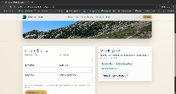
2 | Enter demo@moffatbay.com, phone 5550101, names Test User, password DemoPass1 in both password fields. | All local validation rules pass. | Pass | Pass  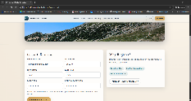
3 | Click Create Account. | API rejects duplicate. Red #register-message says "Email already exists in the database." | Pass | Pass  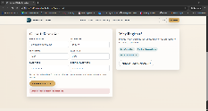
4 | Screenshot the message. | No redirect; existing account is unchanged. | Pass | Pass
Notes | Incognito error messages appear as required.

FT-ERR-07: Contact form: missing information
Objective: Verify server-side required fields and the location of errors.
Step | Action | Expected result | Developer pass/fail | Tester pass/fail + screenshot
1 | Open about.html#contact and scroll to Send an Inquiry. | Contact form is visible under About content. | Pass | Pass  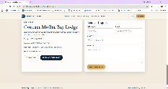
2 | Leave Full Name blank, use valid email/subject/message, click Send Message. | Below Send Message, red #contact-message says "Full name is required." | Pass | Pass  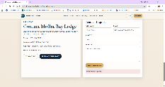
3 | Enter a name, leave Email blank, submit again. | Red message says "Email address is required." | Pass | Pass  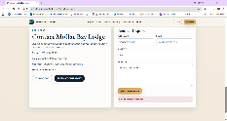
4 | Enter a valid email, leave Subject blank, submit again. | Red message says "Subject is required." | Pass | Pass  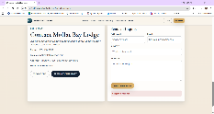
5 | Enter Subject, leave Message blank, submit again. | Red message says "Message is required." | Pass | Pass  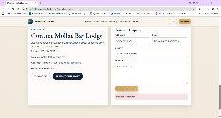
6 | Screenshot at least two distinct messages. | Each error is displayed below Send Message, without claiming success. | Pass | Pass  (see screenshots above)
Notes | All error messages on the contact page display as required.

FT-ERR-08: Booking: missing dates
Objective: Check that booking is blocked without valid travel dates.
Step | Action | Expected result | Developer pass/fail | Tester pass/fail + screenshot
1 | Sign in using demo@moffatbay.com / DemoPass1 and open reservation.html. | Booking form displays wide guest/date fields alongside the selected room photo preview. | Pass | Pass  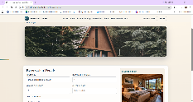
2 | Leave the check-in/check-out date boxes empty. | No dates are selected. | Pass | Pass  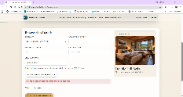
3 | Click Add Room to Reservation. | Red #reservation-message says "Choose a check-in date and a later check-out date first." | Pass | Pass
4 | Screenshot the message. | Nothing is added to the room cart. | Pass | Pass  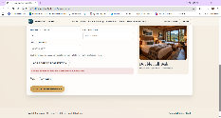
Notes | Booking date error message displays as required

FT-ERR-09: Booking: unavailable quantity
Objective: Check availability errors are clear and prevent adding rooms.
Step | Action | Expected result | Developer pass/fail | Tester pass/fail + screenshot
1 | While signed in on reservation.html, choose dates next month and select Queen. | Room size and future date range are selected. | Pass | Pass  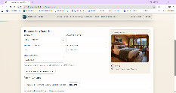
2 | Set Rooms of This Size to 10 and click Add Room to Reservation. | Availability should be denied because the sample database has fewer than 10 Queen rooms. | Pass | Pass  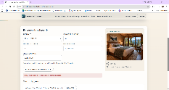
3 | Inspect error below Add Room to Reservation. | Red #reservation-message says "Only [number] Queen room(s) are available for those dates." | Pass | Pass
4 | Screenshot and verify Continue to Summary is disabled. | Request is not added to the cart; proceed is blocked. | Pass | Pass  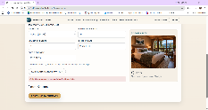
Notes | Room capacity error message displays. Can not proceed to summary.

FT-ERR-10: Reservation Summary: missing saved cart
Objective: Check the empty-summary error state.
Step | Action | Expected result | Developer pass/fail | Tester pass/fail + screenshot
1 | Open a new browser tab at reservation-summary.html without first adding rooms. | No mbl_reservation_cart exists in that tab's session storage. | Pass | Pass  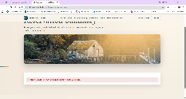
2 | View the summary content below the image. | Red #summary-message states "No reservation to review. Start a new booking from the Book page." | Pass | Pass
3 | Check the Confirm/Cancel actions. | Action controls are hidden. | Pass | Pass  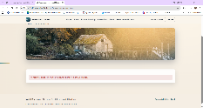
4 | Screenshot the message. | No booking is created. | Pass | Pass  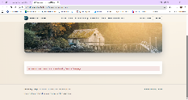
Notes | All error messages display as required.

FT-ERR-11: Reservation History: reversed dates
Objective: Check that incorrect filter dates produce an error above the table.
Step | Action | Expected result | Developer pass/fail | Tester pass/fail + screenshot
1 | Sign in and open reservation-lookup.html. | History and new check-in date filter fields are visible. | Pass | Pass  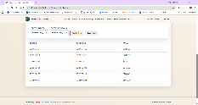
2 | Set Check-in from to 2027-08-01 and Check-in through to 2027-01-01. | Start date is later than end date. | Pass | Pass  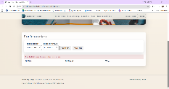
3 | Click Apply Filters. | Red #history-message says "The start date must be on or before the end date." | Pass | Pass
4 | Screenshot error and date inputs. | Table is cleared for the invalid filter; no crash. | Pass | Pass
Notes | Reservation date error displays as required.

FT-ERR-12: Reservation History: no matching results
Objective: Check that the page explains an empty filter result.
Step | Action | Expected result | Developer pass/fail | Tester pass/fail + screenshot
1 | Still signed in on reservation-lookup.html, select both filter dates in 2035. | Dates are in a period with no seed reservations. | Pass | Pass  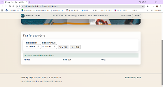
2 | Click Apply Filters. | #history-message says "No reservations match the selected dates." | Pass | Pass
3 | Click Clear Filters. | Inputs reset; matching stored reservations return; previous message clears. | Pass | Pass  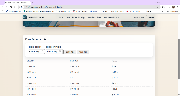
4 | Screenshot the no-results text and restored table. | Filter state is correct and no empty success banner remains. | Pass | Pass  (See Above Screenshot)
Notes | All messages display correctly.

FT-ERR-13: Reservation: guest count exceeds room capacity
Objective: Confirm that the booking page explains an invalid guest count beside the Number of Guests field, while preserving the room photo preview.
Step | Action | Expected result | Developer pass/fail | Tester pass/fail + screenshot
1 | Sign in, open reservation.html, choose future check-in/out dates, then add one Queen room. | The room is added, and the selected room preview displays a Queen room photograph. | Pass | Pass  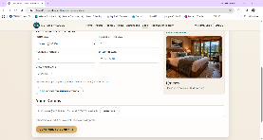
2 | Enter 3 in Number of Guests. | A visible error below Number of Guests says: "Your selected rooms can accommodate up to 2 guests. Adjust the guest count or add another room." | Pass | Pass  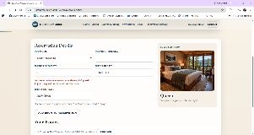
3 | Check Continue to Summary. | Button remains disabled while the guest count exceeds the room capacity. | Pass | Pass  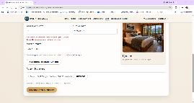
4 | Change Number of Guests back to 2. | Guest capacity warning disappears and Continue to Summary becomes enabled if room availability is confirmed. | Pass | Pass  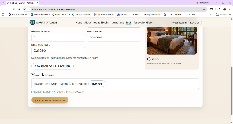
5 | Capture the invalid and corrected states. | Record actual result and screenshots before marking Pass or Fail. | Pass | Pass  